**Title:- BLOOD BANK**

**PROJECT**

NAME:- Snehal Prusty

REG.NO:-2224100019

MCA(Second Year):-Third Semester

PROJECT TITLE:- BLOOD BANK

TOOLS AND TECHNOLOGIES: VS CODE , MongoDB, Express JS , React, NodeJS(MERN)

**Introduction:-**

This project aims to develop a robust Blood Bank Management System utilizing the MERN (MongoDB, Express.js, React.js, Node.js) stack. The system focuses on streamlining the entire blood donation and distribution process, ensuring efficient management of donor records, real-time inventory tracking, and seamless communication between stakeholders. The platform integrates user-friendly interfaces for donors, administrators, and healthcare professionals, enhancing accessibility and usability.

Key features include a dynamic donor registration system, an intelligent inventory management module, and a responsive dashboard for administrators to monitor and analyze blood supply levels. The incorporation of the MERN stack enables scalability, flexibility, and rapid development, ensuring adaptability to evolving technological landscapes.

The project emphasizes data security and confidentiality by implementing encryption protocols and user authentication mechanisms. Additionally, the application explores the integration of SMS or email notifications for donors, encouraging regular participation and fostering a sense of community engagement.

Through this MERN-based Blood Bank Management System, the project aims to contribute to the optimization of blood bank operations, fostering a more resilient and responsive healthcare system. The proposed solution aspires to be a scalable model for blood banks, combining technological innovation with a user-centric approach to positively impact blood donation and distribution practices.

Here we see multiple Roles that is **Doner, Admin, Hospital , Organisation**

**Use Case Diagram :-**

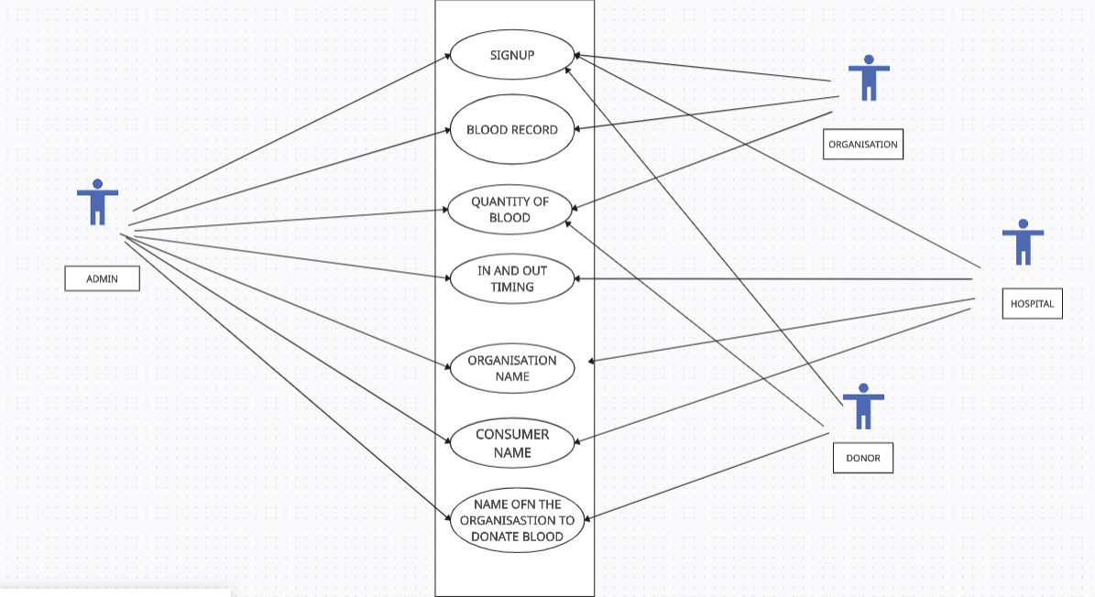

**Funtionnality:-**

**Organisation:-**  Here in which we have to see all the blood records in which type of blood , where is it in and out , what is quantity of blood, who has done in and out here , then see time and date it will show in this way. Here to see all donors in donar, how many doner here

Send application to him, whatever organisation this is . then here to see whichever hospital

Will be registered on it

**Donar:-** here to see which organisation to donate blood see here and it will show where and how much blood you have donate.

**Hospital:-** Hereshow organisation name and we can see the consumer and who has consumed our blood.

**Admin:-** Admin manage the hospital, Doner, Organisation.

Conclusion:-

The conclusion on blood banks is crystal clear—they play a vital role in healthcare. These establishments are the unsung heroes, ensuring a steady supply of blood for various medical needs. From emergencies and surgeries to chronic conditions, the availability of blood can be a matter of life and death. The dedication of donors, the meticulous screening processes, and the efficient distribution channels all contribute to the success of blood banks in saving countless lives. It's a collective effort that deserves appreciation and support from communities worldwide.

Top of Form